

Project Management

Assignment 1



April 4, 2024

VC waterfall Midrand

ST10091991

* 1. **- Importance of a project evaluation forum for View-All.**

According to evalcommunity a project evaluation forum provides multiple benefits such as:

* It identifies areas of interests that could be improved upon or areas that did not provide the expected results (Evalcommunity, 2023). This helps to mitigate the chance of a project from failing by assuring the vulnerabilities in the process of accomplishing the project goals are strengthened (Evalcommunity, 2023).
* It measures the predictable outcomes of a set project which provides valuable insights in what to expect of the project and how the specific project objectives are to be accomplished (Evalcommunity, 2023).
* It provides accountability specifically to project managers and stakeholders to ensure that the projects outcomes are in full responsibility of both parties (Evalcommunity, 2023). In return this ensures that trust between both project managers and stakeholders are built as there is full transparency between both parties (Evalcommunity, 2023).
* It provides reflection on what went well and what did not go well during the project overall process which in turns allows project managers to improve upon their project manager skills (Evalcommunity, 2023).

In conclusion with the supporting statements from Evalcommunity the importance of a project evaluation plan has multiple benefits to View-All such as finding weaknesses in the project and improving upon those weaknesses, to measure the project outcomes and monitor the project achievements/milestones. With View-All aiming to develop a content architecture application it is vital to have a project evaluation form that can help in transparency between project manager and stakeholders to ensure trust and to make sure both parties are focused on the same objectives to accomplish the desired project outcomes.

* 1. – **Advice on bid/no-bid decision.**

4 essential principles to understand when it comes deciding between a bid/no-bid decision that are:

* **Know your competition!**

Understanding your competition is an important aspect of knowing what other organizations / teams do in certain projects, how they handle it and most importantly how much they charge and provide as clients do not really care who does the project all they would care mostly about is how much it costs and how well it can be done (Jones, 2024). This is where you the project manager needs to be aware of the competition in your field and how to give the best possible service with the best possible price so that you in the end get the job instead of your competition, however its important to be mindful that yes you can do it for a lower price but remember that you want to make a profit out of the project so you can only go so low when it comes to price and that price can only give you so much quality also (Jones, 2024). The term for this is called finding the sweet spot where you give a great price with good quality, and you get a profit out of the project which is a win-win situation for both your team and your client (Jones, 2024).

* **What’s the Risk?**  
  Risk management is an essential element in ensuring that you have all the knowledge associated with the project both the good and the bad (Jones, 2024). The first step here is to identify the potential risks associated with the project, once the risk has been identified next is to plan a potential solution that either mitigates, avoids or recovers from the risk as sometimes there might not be an imminent solution to the risk thus avoiding it would help and in certain cases avoiding it may not be possible thus having a recovery approach is the best way to ensure the project continuity and resilience to the associated risks (Jones, 2024).
* **What are my cards?**  
  Ensure that your team or company is not overloaded with projects meaning it is a wise decision to make sure before engaging in a project that you can provide the necessary manpower, equipment, staff and resources into the project to ensure you have the capability to provide all the necessary means to completing the project both in time and efficiently as the client wants it to be done (Jones, 2024).
* **Profitability?**  
  Customer funding is essential when it comes to a project, if a customer is asking for a large project, then obviously the funding will also be required to be much larger as stipulated the quality of a project is determined by time and the time taken is going to be dependent on the money given or available (Jones, 2024). For a project manager its important to make sure there is some form of profitability in the project that you are doing for your client else there is no business bidding to the project in the first place, as stated by Kendall Jones “The bottom line is if you can’t make a profit on a project, you have no business bidding on it in the first place” after all you are going to have a great amount of time and effort placed into the project you might as well make sure its worthwhile (Jones, 2024).
  1. – **Diagram A**  
     A diagram of a company

     Description automatically generated

(Gido et al., 2023)

Availbale link: <https://drive.google.com/file/d/1-R7h91PLnx9XiGiDrALl2EfN1C8fKWUi/view?usp=sharing>

2.1) – **Functional requirements are**:

1. Content Aggregation via the use of an API integration – Allows the integration of various streaming media platform content stated to be streamed and automatically integrated into the application.
2. Personalization – Allows recommendations and personalized content such as viewed content genres and data to be used to recommend similar shows to the user.
3. Secure user profiles – Ensures user account are secured to prevent any security breaches or concerns such as ensuring a strong password, 2FA (2 factor authentication), passkeys and biometrics to be used.
4. User friendly searching and browsing recommendations – Ensuring easy use of services such as easy searching and easy accessibility to watch a selected series.
5. Subscription management – ensuring that only users that have a current subscription (valid license) to be able to watch anything on the platform.

2.2) –

(Gido et al., 2023)

Available link: <https://drive.google.com/file/d/1_fVVmFwL0io5-aLRLmXgjGTXAliDNQ7w/view?usp=sharing>

3.1) –

Overall planning screen

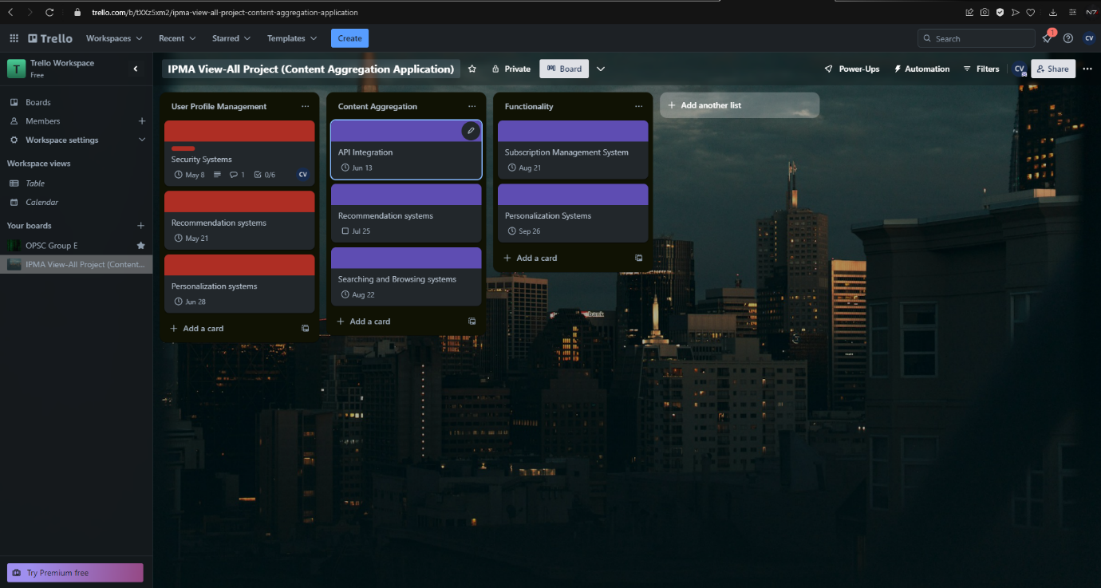

Specific planning card that shows a single deliverable with its work packages and tasks assigned to a specific person.

3.2) –

(Gido et al., 2023)

4.1) – **Development**:

* Phase 1 (Planning Phase): In this stage we will be diving into doing the initial planning such as defining the project scope, objectives and requirnments needed such as how much staff will be needed, resources and equipment. In this stage we will also be diving into planning which system take priority over others based of what the end users are looking for, example is focusing on the API as a main priority because without that API working correctly there wont be any shows or series available for clients to watch which also means the purpose of the app would be pointless if the API didn’t work (wrike, 2024). Once all the pre defines have been set next is to task what needs to be done first, how it needs to be done and when it must be completed (wrike, 2024). Additionally there will be more research done to find out the smaller details of any queries during the stage (wrike, 2024). The respective stakholders will be notified of the completion of the planning phase and once notified be moving on to the next phase (wrike, 2024).
* Phase 2 (Development Phase): In this phase the initial development will commence which will then be the starting point of the application’s life cycle (wrike, 2024). The major tasks would be broken down into smaller sections which will then be assigned each to a team for example the front end GUI will be for the UI design team while the login process will be handled by the backend team etc (wrike, 2024). The minor tasks are a piece of the major tasks thus having more then one section completed at the same time increases the productivity and reducing the time taken to finish the project (wrike, 2024). As the minority pieces are finished they will be submitted to the compiling team which then bind together the front end and backend of the tasks and they start putting the pieces together (wrike, 2024). The stakeholders will be notified of the progress in development and once completed will be informed and await approval (wrike, 2024).
* Phase 3 (Testing Phase): In this phase there will be extensive tests done to ensure the application works as expected, the tests that will be conducted are a variety ranging from blackbox testing to unit and stub testing (wrike, 2024). Once the application works as expected it will then be ready for the final phases of tests that are needed to deem that it works as expected (wrike, 2024). If the tests fail the specific component of where it has failed will then go back to development for corrections and alterations and be re tested till it passes its initial failed test (wrike, 2024). Once all minority components pass their tests the entire application will be taken in for a overall test and the respective stakholders will be notified of the completion of the testing phase (wrike, 2024).
* Phase 4 (Deployment Phase): in this phase the initial deployment of the application will take place where the application will swap from development to production (wrike, 2024). In this phase the initial configuration and deployment of the app to be able to be accessed to the public will take place such as deploying the app in application stores and the applcation’s database will be in a database server while the API will be deployed on a server accessable by the streaming plaforms so that their content will display in the applications database (wrike, 2024).
* Phase 5 (Maintanance and Monitory phase): in this phase the application would have been already completed and deployed and most of the staff and resources would not be needed anymore but only a few individuals would remain to maintain the application and its systems (wrike, 2024). This will mean constant monitoring of systems, performance and stabilitiy checks and occassionally updates to the software where needed to improve the application (wrike, 2024).

**Server Infostructure:**

* Phase 1 (Planning Phase): In this stage the server requirnemnts and other necessary requirnements will be defined which aim to determine the approach and architecture needed to develop the server side aspect of the services (wrike, 2024). Once defined and all the needed information is gathered in order to have a connection with the application then the next stage is ready to commence (wrike, 2024).The necessary stakeholders will be informaed that the planning phase has been complete and await approval for the next stage (wrike, 2024).
* Phase 2 (Development Phase): In this stage there will be the initial setup of the server (physical server) and the setup of the server software which will be used to communicate to the application back and forth (wrike, 2024). The server will follow a specific setup which will have the API access and the normal storing of the database contents and etc, The API will be the link between all applications and processing such as when one of the external streaming companies do update their movies list etc it will then reflect on View-All server (which is the server we are making here) (wrike, 2024). Progress updates reports will be sent to the stakeholders to keep them notified of the development process while the tasks are spread for the teams to complete (wrike, 2024). Once the development stage is complete the stakeholders will be notified and await approval for the next stage (wrike, 2024).
* Phase 3 (Testing Phase): In this phase the server infestructure and functionality will be tested with a variety of needed tests (wrike, 2024). Once all tests are confirmed to work then the server will be ready for official launch and the stakeholders will be notified of the test completions and await further approval when needed (wrike, 2024).
* Phase 4 (Deployment Phase): In this phase the server will be deployed and changed from development to production while the server systems will be monitored to see if there is anything that has been missed be ressolved before the server is fully live to the public (wrike, 2024). The stakeholders will be notified that the server is ready and the sign off will be done if needs be (wrike, 2024).
* Phase 5 (Monitoring and Maintanance): In this phase only a hand full or View-All’s server administrators will then monitor and maintance the server for better performance and stabaility and constant updates will be placed to ensure better quality of life for the server (wrike, 2024).

4.2) **Downfall** **Factors**

* **Scope:** If the scope keeps being expanded upon meaning more functional requirnements are asked of by the stakeholders or more non-functional needs are placed then ultimately a **scope creep** occurs where it continuously expands beyond its original boundaries for example View-All would want an additional 3 or 4 functions to be added which constrains resources and increases the work load thus lowering the chances of completing the work in the deadline (Coursera, 2024). Additionally this will result in **quality compromise** which lowers the quality of the project due to the addition of more and more needs from the stakeholders (Coursera, 2024).
* **Schedule**: The project is set to be completed within 12 months which alrady is a constrain in itself as there is limited time to do a major project however due to there already being a **time constraint** it does not compensate for unforseen challenges wheather being technical, economical, social, resources or any other issue that may or may not happen (Coursera, 2024). With that said if something does happen that can cause a delay in production that means the team would be set back and the production is set back thus there will be pressure on the team and this will result in **rushed development** which will result in affecting the quality of the project (Coursera, 2024).
* **Budget**: With there already being **limited resources** which was stated as View-All is giving a budget of R500 000 which means there is only so much resources at the teams disposal which means the quality of a project is already at a certain capacity reachable and cannot go further then that unless more finances are given (Coursera, 2024). With this limitation this can mean certain functionalities might not work as best as they could have, certain functionalities may be traded off between features thus compromising the quality of the project (Coursera, 2024). The given budget does not compensate for unforseen financial expenses thus making it difficult to maintain to the budget and causing a **cost overrun** that means the project doesn’t cost anymore R500 000 but then R750 000 for example (Coursera, 2024).

5) – **Introduction and Conclusion Self Reflection** :  
  
**Student Introduction** : In the given assignement there were a variety of skills being used such as when reading exactly the case study you start to brainstorm the architecture of which to follow, you start to visualize the blueprints in your mind for example when I read the specifications View-All had set these where placed as primary milestones / objectives that need to be reached while other brainstormed ideas such as security systems etc where kept as a secondary objective that aimed to accomplish a support role in the application. Specific dates where made for each objective considering the 12 month period and with only a specific budget in place the project was limited in terms of additional functionality however it was kept to a point that what was specified by View-All is what will be prioritized into the application architecture. There were many times i wanted to add more features and more functionality however with the R500 000 budget set it was very difficult to add more things as it would cause over spending and thus reduce project quality as i stated the issues were in question 4.2.  
  
**Skills learnt**:  
Brainstorming to calculate and expand upon  
Staff meetings brief and debrief to inform  
Time management to plan and meet deadlines  
Risk management to mitigate a potential issue  
  
**Tasks I did well in**:  
1. Managed to plan deadlines appropriately given the time deadline and limited time given.  
2. Managed to task accordingly and specify details where needs be.  
  
**List of personal Strengths**:  
Time Management  
Leadership  
Communication  
Research  
Resilience  
  
**Tasks I didn’t do well in**:Struggled to specify details in terms of system architecture due to insufficient expereince however research helped uncover that.  
  
**How to improve**:Simply research and understanding how and why certain architectures are applied in certain scenarios.

**Student Conclusion**: Overall the project assignment went well as expected, There were some hickups along the way however they were easily ressolved and easily overcomed. In short if I was to do this project in actual with actual suporting roles and developers I strongly believe it would be done and very well done however what I have realized about myself is I need to keep it specific to what is asked and not go overboard with features and functionalities as there is limited time, resources and capabilities placed and the reality is that its true if there is only a certain amount given then there is only a certain amount that can be accomplished additionally. I also learnt prioritization which with what is considered first to be done over others as there is also a factor of team morale and fatigue that can happen so its always recommended to do exactly as what was asked and not more cause (A) they wont pay for extra and (B) you don’t want to tire out your team during the process as it is time consuming and brain consuming if there is more to be donebut no reward for it which then makes the work underpayed which isnt fair to the team you lead. Ive learned to be a leader is not an easy job as you have to be both the good cop and bad cop at times however most importantly is equally fair.

**Student self rating / 10**: 8/10

**Reference List**

Coursera (2024) *What is the Project Management Triangle?*, *Coursera*. Available at: https://www.coursera.org/articles/project-management-triangle (Accessed: 01 April 2024).

Evalcommunity (2023) *Project evaluation - Evalcommunity Evalcommunity*, *EvalCommunity*. Available at: https://www.evalcommunity.com/career-center/project-evaluation/#:~:text=Project%20evaluation%20is%20an%20important%20process%20that%20offers%20a%20number,future%20projects%20are%20more%20successful. (Accessed: 29 March 2024).

Gido, J. *et al.* (2023) ‘Chapter 4 - Defining Scope, Quality, Responsibility and Activity Sequence ’, in *Successful Project Management in South Africa*. 2nd edn. Hampshire, United Kingdom: Cengage (1), pp. 104–141. Available at: N/A (Accessed: 2024).

Jones, K. (2024) *5 key factors to consider in bid/no-bid decision making*, *ConstructConnect, Construction Project Management Software*. Available at: https://www.constructconnect.com/blog/key-factors-consider-bidno-bid-decision-making (Accessed: 31 March 2024).

wrike (2024) *The Agile Software Development Life Cycle: Wrike Agile Guide*, *Versatile & Robust Project Management Software*. Available at: https://www.wrike.com/agile-guide/agile-development-life-cycle/ (Accessed: 31 March 2024).